**VIRTUAL VOICE ASSISTANT (using python)**

**A PROJECT REPORT**

Submitted in partial fulfillment of the requirements for the award of the degree of

#### Bachelor of Technology

*in*

##### COMPUTER SCIENCE AND ENGINEERING

## BY

**YALLA JAYANTHI V.V.S CHANDRA MOULI**

**21331A05I8 21331A05I0**

**PAMU CHANDU V SAIGANESH**

**21331A05D6 21331A05I4**

## Under the Supervision of

## Dr. P. Rama Santosh Naidu

**Senior Assistant Professor**



**DEPARTMENT OF COMPUTER SCIENCE AND ENGINEERING**

## MAHARAJ VIJAYARAM GAJAPATHI RAJ COLLEGE OF ENGINEERING (Autonomous)

## (Approved by AICTE, New Delhi, and permanently affiliated to JNTUGV, Vizianagaram), Listed u/s 2(f) & 12(B) of UGC Act 1956.

## Vijayaram Nagar Campus, Chintalavalasa,Vizianagaram-535005, Andhra Pradesh

## APRIL, 2024

**CERTIFICATE**



This is to certify that the project report entitled “**VIRTUAL VOICE ASSISTANT (using python)”** being submitted by Y. Jayanthi (21331A05I8), V.V.S Chandra Mouli (21331A05I0), Pamu Chandu (21331A05D6) and V. Saiganesh(21331A05I4) in partial fulfillment for the award of the degree of “**Bachelor of Technology” in Computer Science and Engineering** is a record of bonafide work done by them under my supervision during the academic year 2023-2024

#### 

#### 

**Dr. P. Rama Santosh Naidu Dr. T. Pavan Kumar**

**Senior Assistant Professor, Associate Professor,**

**Supervisor, Head of the Department,**

Department of CSE, Department of CSE,

MVGR College of Engineering(A), MVGR College of Engineering(A),

Vizianagaram. Vizianagaram.

**External Examiner**

**DECLARATION**

We hereby declare that the work done on the dissertation entitled “**VIRTUAL ASSISTANT**” has been carried out by us and submitted in partial fulfilment for the award of credits in Bachelor of Technology in Computer Science and Engineering of MVGR College of Engineering (Autonomous) and affiliated to JNTUGV, Vizianagaram. The various contents incorporated in the dissertation have not been submitted for the award of any degree of any other institution or university.

**ABSTRACT**

The development of a Virtual Voice Assistant for our laptop in a world dominated by technology, having a reliable and personalized assistant can greatly enhance productivity and make everyday tasks more convenient. Our virtual assistant is designed to seamlessly integrate with our laptops, responding to voice commands and providing a range of useful features. The Virtual Assistant for Laptops outlines a groundbreaking solution to the pressing social issue of accessibility, inclusivity, and efficiency in technology usage. By introducing a voice-activated interface, the project targets users with physical disabilities and those less familiar with traditional computing methods, creating a more natural and intuitive interaction with laptops. We are going to use Python for the code outlines using different modules which are mentioned below. The integration of the Wikipedia API and entertainment features addresses broader challenges, including language barriers and the need for engaging user experiences. Additionally, the project contributes to efficiency through task automation, catering to professionals and users with privacy concerns. With a focus on a user-friendly interface, the abstract underscores the project's commitment to inclusivity, making advanced technology accessible to a diverse audience and thus significantly contributing to narrowing the digital divide.

**CONTENTS**

**Page No**

**1. Introduction**

1.1. OVERVIEW 03

1.2. DESIGN 04

1.3. VOICE ASSISTANT

1.3.1 WHAT IS VOICE ASSISTANT 04

1.3.2 WHY DO WE NEED IT 04

1.3.3 WHERE TO USE IT 04

**2. Literature Survey 05**

**3. Theoretical Background 09**

3.1. EXISTING SYSTEM 09

3.2. PROPOSED SYSTEM 10

3.3. OBJECTIVE OF THE PROJECT 10

3.4. SOFTWARE AND HARDWARE REQUIREMENTS 10

3.4.1. SOFTWARE REQUIREMENTS 11

3.4.2. HARDWARE REQUIREMENTS 11

3.4.3. LIBRARIES 11

3.5. PROGRAMMING LANGUAGES

3.5.1. PYTHON 12

3.5.2. DOMAIN 12

**4. Approach Description 13**

**5. Data Exploration 15**

**6. Modelling**  18

**7. Results and Conclusions**

7.1 CONCLUSION 20

7.2 FUTURE SCOPE **20**

**8. References 22**

**9. Appendix (Sample Outputs) 23**

**CHAPTER 1**

**INTRODUCTION**

The very first voice-activated product was released in 1922 as Radio Rex. This toy was very simple, wherein a toy dog would stay inside a dog house until the user exclaimed its name, “Rex” at which point it would jump out of the house. This was all done by an electromagnet tuned to the frequency similar to the vowel found in the word Rex, and predated modern computers by over 20 years. In the 21st century, human interaction is being replaced by automation very quickly. One of the main reasons for this change is performance. There’s a drastic change in technology rather than advancement. In today’s world, we train our machines to do their tasks by themselves or to think like humans using technologies like Machine Learning, Neural Networks, etc. Now in the current era, we can talk to our machines with the help of virtual assistants. Virtual assistants are software programs that help you ease your day-to-day tasks, such as showing weather reports, giving daily news, searching the internet etc. They can take commands by voice. Voice-based intelligent assistants need an invoking word or wake word to activate the listener, followed by the command. We have so many virtual assistants, such as Apple’s Siri, Amazon’s Alexa and Microsoft’s Cortana and Amazon's Alexa and this has been an inspiration for us to do this as a project. This system is designed to be used efficiently on desktops. Voice assistants are programs on digital devices that listen and respond to verbal commands. A user can say, “What's the weather?” and the voice assistant will answer with the weather report for that day and location.

1.1 OVERVIEW

A disease is a condition that affects the individual functioning of body totally. Diseases if neglected will lead to the death of an individual. Diseases can be identified by the symptoms of the body of an individual. Health is the most important in every human’s life. Weekly or monthly check up of one’s health is most important for the prevention and also to stay healthy. Healthcare is the most crucial parts of the human life. The traditional way of diagnosis may not be sufficient in the case of a serious ailment. There are also some remote villages which lack medical facilities. The dataset was processed in ML models Naive Bayes and Decision Tree. While processing the data, symptoms are given as input and the disease was received as an output. This project helps to get the idea about the disease of an individual based on the symptoms he/she have, and get the treatment easily by contacting the concern doctor.

1.2 DESIGN

a) The voice assistant takes an input word which is called as "signal word" to be activated. so, it takes in the signal word and starts operating for the user commands. b) Converting the speech into text will be processed by the assistant. c) The converted text is now processed to get the required results. d) The text given by the user should contain one or two keywords that determine what query is to be executed. If the keyword doesn’t match any of the queries in the code then the assistant asks the user to speak again. e) Finally, the output to the user's query will be given by converting speech to text. 1.3 VOICE ASSISTANT Our assistant “NOVA” extends to helps us when working on a system in which it is installed. We can access by calling the wake word "Hello NOVA".

1.3 WHAT IS VOICE ASSISTANT

A voice assistant, also known as an intelligent personal assistant or a connected speaker, is a new type of device that is based on natural language speech recognition and is offered by popular companies like Apple, Amazon, and Google. We got inspired by that and created one our self. 1.3.2 WHY DO WE NEED IT Usually, typing out and searching or doing day-to-day tasks becomes hectic. But our life doesn’t need to be like that. One can ask for help to voice assistants. They let the users to perform a task using a speech command, as well as retrieve information via voice synthesis. 3 Following are the reasons to have a voice assistant. • Minimal Effort ¬ It’s easier to say a few words than type them on a small smartphone screen. • Eyes Free One can be as blind as a bat, but a voice assistant will always help you. Our ears are enough. One can also ask the bot about something while cooking at the same time. • Fast response ¬ Imagine how much time you have to spend to find some information on a website? Or how many clicks do you need to make before you find the thing you need in a mobile application? Voice assistants don’t generate such difficulties. One can ask a question and you have the answer.

1.3.3 WHERE TO USE IT

Voice search has been a hot topic of discussion. Voice visibility will undoubtedly be a challenge. This is due to the lack of a visual interface for voice assistants. Users cannot see or interact with a voice interface unless it is linked to the Alexa or Google Assistant app. Search behavior patterns will change dramatically as a result. Brands are currently undergoing a transformation in which touchpoints are transforming into listening points, and organic search will be the primary means of brand visibility. Advertising agencies are becoming more popular as voice search grows in popularity. Voice assistants will also continue to offer more individualized experiences as they get better at differentiating between voices. The number of people using voice assistants is expected to grow. According to the Voice bot Smart Speaker Consumer Adoption Report 2018, almost ten percent of people who do not own a smart speaker plan to purchase one. If this holds true, the user base of smart speaker users will grow 50 percent, meaning a quarter of adults in the United States will own a smart speaker.

**CHAPTER 2**

**LITERATURE SURVEY**

This field of virtual assistants having speech recognition has seen some major advancements or innovations. This is mainly because of its demand in devices like smartwatches or fitness bands, speakers, Bluetooth earphones, mobile phones, laptop or desktop, television, etc. Almost all the digital devices which are coming nowadays are coming with voice assistants which help to control the device with speech recognition only. A new set of techniques is being developed constantly to improve the performance of voice automated search.

As the amount of data is increasing exponentially now known as Big Data the best way to improve the results of virtual assistants is to incorporate our assistants with machine learning and train our devices according to their uses. Other major techniques that are equally important are Artificial Intelligence, Internet of Things, Big Data access and management, etc. With the use of voice assistants, we can automate the task easily, just give the input to the machine in the speech form and all the tasks will be done by it from converting your speech into text form to taking out keywords from that text and execute the query to give results to the user.

Machine Learning is just a subset of Artificial Intelligence. This has been one of the most helpful advancements in technology. Before AI we were the ones who were upgrading technology to do a task but now the machine is itself able to counter new tasks and solve it without need to involve the humans to evolve it.

This has been helpful in day-to-day lifestyle. From mobile phones to personal desktops to mechanical industries these assistants are in very much demand for automating tasks and increasing efficiency.

* Nivedita Singh (2021) et al. proposed a voice assistant using python speech to text (STT) module and had performed some api calls and system calls which has led to developing a voice assistant using python which allows the user to run any type of command through voice without interaction of keyboard. This can also run on hybrid platforms. Therefore, this paper lacks in some parts like the system calls that aren’t much supported.
* Abeed Sayyed (2021) et al. presented a paper on Desktop Assistant AI using python with IOT features and also used Artificial Intelligence (AI) features along with a SQLite DB with the use of Python. This Project has a Database connection and a query framework but lacks API call and System calls features.
* P.Krishnaraj (2021) et al. presented a project on Portable Voice Recognition with GUI Automation, This system uses Google’s online speech recognition system for converting speech input to text along with Python. Therefore, this project has a GUI and is also has a portable framework. Accuracy of this text to speech (TTS) engine is comparatively less and also lacks IoT.
* Rajdip Paul (2021) et al. presented a project named A Novel Python-based Voice Assistance System for reducing the Hardware Dependency of Modern Age Physical Servers. This Author has proposed assistant project with python as a backend supporting system calls, api calls and various features. This Project is quite well responsive with api calls, also needs improvement in understanding and reliability.
* V. Geetha (2021) et al. presented a project named The Voice Enabled Personal Assistant for Pc using Python. This Author has proposed assistant project with python as a backend and features like turning our PC off, or restarting it, or reciting some latest news, are just one voice command away. Also, this project has well supported library not every API will have the capability to convert the raw JSON data into text. And there is a delay in processing request calls.
* Dilawar Shah Zwakman (2021) et al. proposed the Usability Evaluation of Artificial Intelligence‑Based Voice Assistants which can give proper response to the user's request. It also has a feature where it can make an appointment with the person mention by the user through voice but it lacks API calls.
* Dimitrios Buhalis (2021) et al. proposed a paper on In-room Voice-Based AI Digital Assistants Transforming On-Site Hotel Services and Guests’ Experiences. Where voice assistant is used for hotel services. It'll be very useful in this current COVID-19 era. Human Touch is considered as a danger in this COVID time and with a voice assistant, loss of human touch is not considered as an advantage. It can also be used to control the temperature controls and room light controls but it needs Complex Integration and Staff Training.
* Philipp Sprengholz (2021) et al. has proposed Ok Google: Using virtual assistants for data collection in psychological and behavioral research which is a survey mate that they have developed which is an extension of the Google Assistant that was used to check the reliability and validity of data collected by this test. Possible answers and synonyms are defined for every different type of questions so, it can be used to analyses the behavior of an individual. As it is a psychological and behavioral research assistant.
* Rahul Kumar (2020) et al. has proposed Power Efficient Smart Home with voice assistant by which we can say that a Voice Assistant is one of the important part of the Smart home which is becoming one of the major things in the current world as it can operate the Home Appliances just with voice which also increase the home security because of the smart locks but it requires a reliable internet connection which is crucial and sometimes, the user might lock themselves out of their own house.
* Benedict D. C (2020) et al. proposed Consumer decisions with artificially intelligent voice assistants that will have stronger psychological reactions to the system's look on human like behaviours. The assistant has an IoT (Internet of Things) features. It can also order stuffs which the user want but there are some cons in this paper. Voice assistant relies on the speaker’s ability to represent the decision alternatives to catch up in voice dialogues and another main disadvantage is that, it lacks system calls.

**CHAPTER 3**

**THEORETICAL BACKGROUND**

3.1 EXISTING SYSTEM

From the above literature survey, we have inferred that all the systems existing predict only particular diseases namely lung disease, breast cancer, heart disease, and diabetes by implementing various algorithms on the particular datasets. After implementing various algorithms, the most accurate one is selected and it is used for prediction of disease. Sometimes, we may get confused of what algorithm to use. Also, all the systems find only the particular disease and not the disease based on the symptoms.

3.2 PROPOSED SYSTEM

We are proposing a system in an efficient way of implementing a Personal voice assistant, Speech Recognition library has many in-built functions, that will let the assistant understand the command given by user and the response will be sent back to user in voice, with Text to Speech functions. When assistant captures the voice command given by user, the under lying algorithms will convert the voice into text. And according to the keywords present in the text (command given by user), respective action will be performed by the assistant. This is made possible with the functions present in different libraries. Also, the assistant was able to achieve all the functionalities with help of some API’s. We had used these APIs for functionalities like performing calculations, extracting news from web sources, and for telling the weather. We will be sending a request, and through the API, we’re getting the respective output. API’s like WOLFRAMALPHA, are very helpful in performing things like calculations, making small web searches. And for getting the data from web. In this way, we are able to extract news from the web sources, and send them as input to a function for further purposes. Also, we have libraries like Random and many other libraries, each corresponding to a different technology. We used the library OS to implement Operating System related functionalities like Shutting down a system, or restarting a system. 8 At the outset we make our program capable of using system voice with the help of sapi5 and pyttsx3. pyttsx3 is a text-to-speech conversion library in Python. Unlike alternative libraries, it works offline, and is compatible with both Python 2 and 3. The Speech Application Programming Interface or SAPI is an API developed by Microsoft to allow the use of speech recognition and speech synthesis within Windows applications. Then we define the speak function to enable the program to speak the outputs. After that we will define a function to take voice commands using the system microphone. The main function is then defined where all the capabilities of the program are defined. • The proposed system will have the following functionality: (a) The system will keep listening for commands and the time for listening is variable which can be changed according to user requirements. (b) If the system is not able to gather information from the user input it will keep asking again to repeat till the desired number of times. (c) The system can have both male and female voices according to user requirements. (d) Features supported in the current version include playing music, texts, search on Wikipedia, or opening system installed applications, opening anything on the web browser, etc.

3.3 OBJECTIVE OF PROJECT

Main objective of building personal assistant software (a virtual assistant) is using semantic data sources available on the web, user generated content and providing knowledge from knowledge databases. The main purpose of an intelligent virtual assistant is to answer questions that users may have. This may be done in a business environment, for example, on the business website, with a chat interface. On the mobile platform, the intelligent virtual assistant is available as a call-button operated service where a voice asks the user “What can I do for you?” and then responds to verbal input. Virtual assistants can tremendously save you time. We spend hours in online research and then making the report in our terms of understanding. 9 Provide a topic for research and continue with your tasks while the assistant does the research. Another difficult task is to remember test dates, birthdates or anniversaries. It comes with a surprise when you enter the class and realize it is class test today. Just tell assistant in advance about your tests and she reminds you well in advance so you can prepare for the test. One of the main advantages of voice searches is their rapidity. In fact, voice is reputed to be four times faster than a written search: whereas we can write about 40 words per minute, we are capable of speaking around 150 during the same period of time. In this respect, the ability of personal assistants to accurately recognize spoken words is a prerequisite for them to be adopted by consumers.

3.4 SOFTWARE AND HARDWARE REQUIREMENTS

3.4.1 Software Requirements:

* Python 3.5 & Above
* Windows 7 And Above

3.4.2 Hardware Requirements:

* Processor: Intel Core i5
* RAM: 4GB
* OS: Windows / Mac
* Microphone
* ARDUINO UNO board
* Relay
* A Light Bulb
* USB Cable
* Electronics Wires
* Plug Point & a Plug

3.4.3 Libraries:

* Pyttsx3- It is a text to speech conversion library in python which is used to convert the text given in the parenthesis to speech. It is compatible with python 2 and 3. An application invokes the pyttsx3.init() factory function to get a reference to a pyttsx3. it is a very easy to use tool which converts the entered text into speech. The pyttsx3 module supports two voices first is female and the second is male which is provided by “sapi5” for windows. Command to install: - pip install pyttsx3 It supports three TTS engines: - sapi5- To run on windows nsss - NSSpeechSynthesizer on Mac OS X espeak – eSpeak on every other platform
* Speech_recognition- It allows computers to understand human language. Speech recognition is a machine's ability to listen to spoken words and identify them. We can then use speech recognition in Python to convert the spoken words into text, make a query or give a reply. Python supports many speech recognition engines and APIs, including Google Speech Engine, Google Cloud Speech API. Command to install :- pip install SpeechRecognition
* Datetime- This module is used to get the date and time for the user. This is a built-in module so there is no need to install this module externally. Python Datetime module supplies classes to work with date and time. Date and datetime are an object in Python, so when we manipulate them, we are actually manipulating objects and not string or timestamps.
* Random2- Python version 2 has a module named "random". This module provides a Python 3 ported version of Python 2.7's random module. It has also been back-ported to work in Python 2.6. In Python 3, the implementation of randrange() was changed, so that even with the same seed you get different sequences in Python 2 and 3. ⎫ Math- This is a built-in module which is used to perform mathematical tasks. For example, math.cos() which returns the cosine of a number or math.log() returns the natural logarithm of a number, or the logarithm of number to base.
* Time- This module many ways of representing time in code, such as objects, numbers, and strings. It also provides functionality other than representing time, like waiting during code execution and measuring the efficiency of our code. This is a built-in module so the installation is not necessary.
* Wikipedia :-This is a Python library that makes it easy to access and parse data from Wikipedia. Search Wikipedia, get article summaries, get data like links and images from a page, and more. Wikipedia is a multilingual online encyclopedia. Command to install :- pip install wikipedia ⎫ Selenium Webdrive- The selenium module is used to automate web browser interaction from Python. Several browsers/drivers are supported (Firefox, Chrome, Internet Explorer), as well as the Remote protocol. The supported python versions are python 3.5 and above. Command to install :- pip install selenium
* Webbrowser- Webbrowser module is a convenient web browser controller. It provides a high-level interface that allows displaying Web-based documents to users. webbrowser can also be used as a CLI tool. It accepts a URL as the argument with the following optional parameters: -n opens the URL in a new browser window, if possible, and -t opens the URL in a new browser tab. This is a built-in module so installation is not required. 13 3.5. PROGRAMMING LANGUAGES

3.5.1 PYTHON

Python is an OOPs (Object Oriented Programming) based, high level, interpreted programming language. It is a robust, highly useful language focused on rapid application development (RAD). Python helps in easy writing and execution of codes. Python can implement the same logic with as much as 1/5th code as compared to other OOPs languages. Python provides a huge list of benefits to all. The usage of Python is such that it cannot be limited to only one activity. Its growing popularity has allowed it to enter into some of the most popular and complex processes like Artificial Intelligence (AI), Machine Learning (ML), natural language processing, data science etc. Python has a lot of libraries for every need of this project. For this project, libraries used are speech recognition to recognize voice, Pyttsx for text to speech, selenium for web automation etc. It’s owing to the subsequent strengths that Python has – ⎫ Easy to be told and perceive- The syntax of Python is simpler; thence it's comparatively straightforward, even for beginners conjointly, to be told and perceive the language. ⎫ Multi-purpose language − Python could be a multi-purpose programing language as a result of it supports structured programming, object-oriented programming yet as practical programming. ⎫ Support of open supply community − As being open supply programing language, Python is supported by awfully giant developer community. Because of this, the bugs square measure simply mounted by the Python community. This characteristic makes Python terribly strong and adaptative.

3.5.2 DOMAIN

The internet of things, or IoT, is a system of interrelated computing devices, mechanical and digital machines, objects, animals or people that are provided with unique identifiers (UIDs) and the ability to transfer data over a network without requiring human-to-human or human-to-computer interaction. A thing in the internet of things can be a person with a heart monitor implant, a farm animal with a biochip transponder, an automobile that has built in sensors to alert the driver when tire pressure is low or any other natural or man-made object that can be assigned an Internet Protocol (IP) address and is able to transfer data over a network. Increasingly, organizations in a variety of industries are using IoT to operate more efficiently, better understand customers to deliver enhanced customer service, improve decision-making and increase the value of the business. An IoT ecosystem consists of web-enabled smart devices that use embedded systems, such as processors, sensors and communication hardware, to collect, send and act on data they acquire from their environments. IoT devices share the sensor data they collect by connecting to an IoT gateway or other edge device where data is either sent to the cloud to be analysed or analysed locally. Sometimes, these devices communicate with other related devices and act on the information they get from one another. The devices do most of the work without human intervention, although people can interact with the devices -- for instance, to set them up, give them instructions or access the data.

**CHAPTER 4**

**APPROACH DESCRIPTION**

* The system will keep listening for commands and the time for listening is variable which can be changed according to user requirements.
* If the system is not able to gather information from the user input it will keep asking again to repeat till the desired number of times.
* The system can have both male and female voices according to user requirements.
* Features supported in the current version include clicking photos, opening files , shutdown the system by closing all the files and can keep it in sleep mode opening anything in the web browser which are mentioned, and so on are all supported in the present edition.

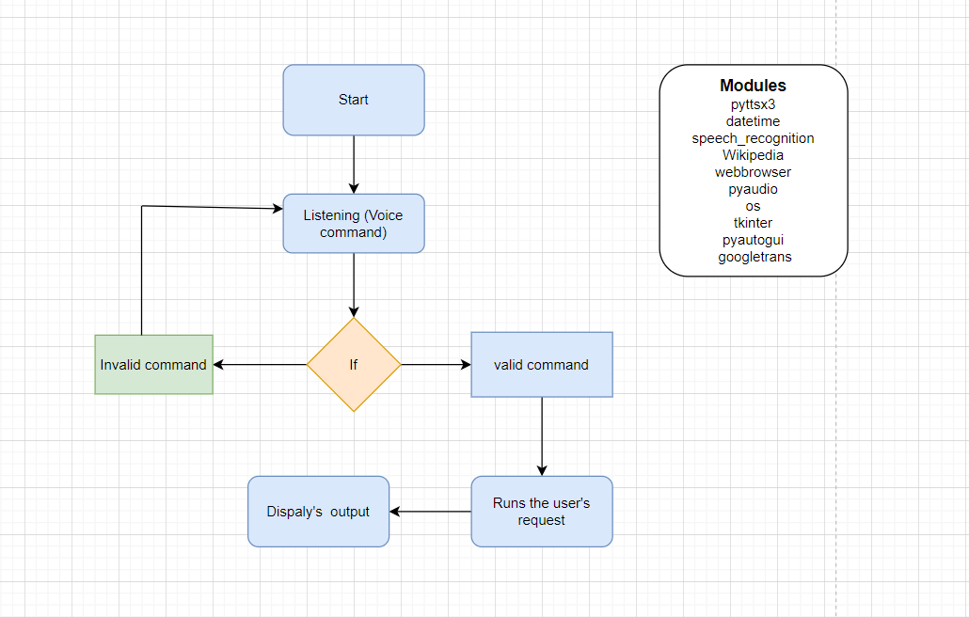

**CHAPTER 5**

**DATA EXPLORATION**

pyttsx3 ; is a Python library that allows us to convert text to speech. So we will be providing it our text and it will convert that text into audio. It's a wrapper around several text-to-speech engines, including Microsoft's Text-to-Speech (TTS) engine.

datetime: datetime in Python is the combination between dates and times. The attributes of this class are similar to both date and separate classes. These attributes include day, month, year, minute, second, microsecond, hour, and tzinfo.

Speech_recogination: Speech recognition is a machine's ability to listen to spoken words and identify them. You can then use speech recognition in Python to convert the spoken words into text, make a query or give a reply. You can even program some devices to respond to these spoken words.

Wikipedia: a Python library that makes it easy to access and parse data from Wikipedia. Search Wikipedia, get article summaries, get data like links and images from a page, and more. Wikipedia wraps the MediaWiki API so you can focus on using Wikipedia data, not getting it. >>> import wikipedia >>> print wikipedia.

Web browser: The webbrowser module provides a high-level interface to allow displaying web-based documents to users. Under most circumstances, simply calling the open() function from this module will do the right thing.

Os : Python has a built-in os module with methods for interacting with the operating system, like creating files and directories, management of files and directories, input, output, environment variables, process management, etc.

Winshell : the winshell module is a light wrapper around the Windows shell functionality. It includes convenience functions for accessing special folders, for using the shell's file copy, rename & delete functionality, and a certain amount of support for structured storage.

Subprocess: The Python subprocess module is a tool that allows you to run other programs or commands from your Python code. It can be used to open new programs, send them data and get results back. It's like giving commands to your computer using Python instead of typing them directly into the command prompt.

Wolframalpha: The Python subprocess module is a tool that allows you to run other programs or commands from your Python code. It can be used to open new programs, send them data and get results back. It's like giving commands to your computer using Python instead of typing them directly into the command prompt.

Ctypes;

ctypes is a foreign function library for Python. It provides C compatible data types, and allows calling functions in DLLs or shared libraries. It can be used to wrap these libraries in pure Python.

Time:

In Python, the time() function returns the number of seconds passed since epoch (the point where time begins). For the Unix system, January 1, 1970, 00:00:00 at UTC is epoch. In the above example, we have used the time.time() function to get the current time in seconds since the epoch, and then printed the result.

Requests:

The requests module allows you to send HTTP requests using Python. The HTTP request returns a Response Object with all the response data (content, encoding, status, etc).

##### Shutil:

##### the Shutil module allows you to do high-level operations on a file, such as copy, create, and remote operations. It falls within the umbrella of Python's basic utility modules. This module aids in the automation of the copying and deleting of files and folders

client:

A Python client refers to an application that is written in Python, a popular programming language. Python is popular because of the high level of abstraction available and the extensive library support. A Python client library is a piece of pre-written code also known as a sub-routine or module.

Ecapture:

To capture images from your Camera

Beautiful soup: Beautiful Soup is a Python package for parsing HTML and XML documents. It creates a parse tree for parsed web pages based on specific criteria that can be used to extract, navigate, search, and modify data from HTML, which is mostly used for web scraping.

Window32com: The win32com package is a set of Python source files that use the pythoncom module to provide additional services to the Python programmer. As in most Python packages, win32com has a number of subpackages; win32com.

Urlopen: This Python module defines the classes and functions that help in the URL actions. The urlopen() function provides a fairly simple interface. It is capable of retrieving URLs with a variety of protocols.

Tikinter:

Tkinter is the first option for a lot of learners and developers because it is quick and convenient to use. Tkinter is a Python library that can be used to construct basic graphical user interface (GUI) applications. In Python, it is the most widely used module for GUI applications.

**CHAPTER 6**

**MODELLING**

Design Considerations: In designing our virtual voice assistant, several key considerations guided our decisions. We prioritized creating a user-friendly and intuitive interface to ensure a seamless interaction experience for users. Additionally, we aimed to integrate a diverse range of functionalities while maintaining simplicity and efficiency in the user interface design. Considering the target audience, we focused on implementing features that are most relevant and useful in everyday tasks, such as information retrieval, web browsing, and task automation.

User Interaction Model: The user interaction model of our virtual assistant revolves around natural language processing and speech recognition technologies. Users can interact with the assistant using voice commands or text input. Upon receiving a command, the assistant processes the input to understand user intent and execute the corresponding action. The dialogue flow is designed to be conversational, with the assistant providing prompt responses and guidance throughout the interaction.

Dialogue Flow: Our virtual assistant follows a structured dialogue flow to effectively handle user requests. Upon receiving a command, the assistant analyzes the input, identifies the task to be performed, and executes the necessary actions. If clarification or additional information is required, the assistant prompts the user for input. Error handling mechanisms are integrated to handle unexpected inputs or errors gracefully, providing informative messages to guide users back on track.

State Management: To maintain context and coherence during interactions, our virtual assistant employs state management techniques. It keeps track of the conversation history, user preferences, and session-specific data to provide personalized responses and adapt its behavior over time. State transitions occur dynamically based on user inputs and system responses, ensuring smooth navigation through various interaction stages.

Error Handling: Robust error handling mechanisms are implemented to address potential issues during user interactions. The virtual assistant detects errors, such as unrecognized commands or failed tasks, and responds with informative messages to guide users toward successful interactions. Error recovery strategies are employed to gracefully handle unexpected situations and prevent user frustration.

Feedback Mechanisms: Feedback mechanisms are integral to our virtual assistant to enhance user experience and improve system performance. Users receive feedback through confirmation messages, error notifications, and prompts for additional input, ensuring clarity and transparency in communication. Additionally, provisions are made for collecting user feedback to gather insights and iterate on the assistant's functionalities.

Personalization and Adaptation: Our virtual assistant offers personalization features to tailor the user experience according to individual preferences and usage patterns. It adapts its responses and behavior based on user history, context, and preferences, providing a customized interaction experience. Machine learning algorithms are utilized to continuously learn from user interactions and improve the assistant's performance over time.

Scalability and Extensibility: The architecture of our virtual assistant is designed to scale and accommodate future growth in user base and functionality. It supports modular development, allowing for the seamless integration of new features and services. Extensibility is ensured through APIs and plugin architectures, enabling developers to extend the assistant's capabilities by adding new functionalities or integrating with external services.

**CHAPTER 7**

**RESULTS AND CONCLUSIONS**

7.1. CONCLUSION

As stated before, "voice assistant is one of the biggest problem solvers" and you can see that in the proposals with the examples that it is one of the biggest problem solvers of the current world. We can see that voice assistant is one of the major evolving artificial intelligence in the current world once again on seeing the proposal examples because in the past, the best feature that a voice assistant had was telling the date searching the web and giving the results but now look at the functions that it can do so with this, we can say that it is a evolving software in the current world. The main idea is to develop the assistant even more advanced than it is now and make it the best AI in the world which will save ample of time for its users. I would like to conclude with the statement that we will try our best and give one of the best voice assistants which we are able to.

7.2. FUTURE SCOPE

We are entering the era of implementing voice-activated technologies to remain relevant and competitive. Voice-activation technology is vital not only for businesses to stay relevant with their target customers, but also for internal operations. Technology may be utilized to automate human operations, saving time for everyone. Routine operations, such as sending basic emails or scheduling appointments, can be completed more quickly, with less effort, and without the use of a computer, just by employing a simple voice command. People can multitask as a result, enhancing their productivity. Furthermore, relieving employees from hours of tedious administrative tasks allows them to devote more time to strategy meetings, brainstorming sessions, and other jobs that need creativity and human interaction.

1) Sending Emails with a voice assistant: Emails, as we all know, are very crucial for communication because they can be used for any professional contact, and the finest service for sending and receiving emails is, as we all know, GMAIL. Gmail is a Google-created free email service. Gmail can be accessed over the web or using third-party apps that use the POP or IMAP protocols to synchronize email content. To integrate Gmail with Voice Assistant we have to utilize Gmail API. The Gmail API allows you to access and control threads, messages, and labels in your Gmail mailbox.

2) Scheduling appointments using a voice assistant: The demands on our time increase as our company grows. A growing number of people want to meet with us. We have a growing number of people who rely on us. We must check in on certain projects or set aside time to chat with possible business leads. There won't be enough hours in the day if we keep doing things the old way. We need to get a better handle on our full-time schedule and devise a strategy for arranging appointments that doesn't interfere with our most critical job. By working with a virtual scheduler or, in other words, a virtual assistant, we let someone else worry about the organization and prioritize our schedule while we focus on the work.

3) Improved Interface of a voice assistant (VUI): Voice user interfaces (VUIs) allow users to interact with a system by speaking commands. VUIs include virtual assistants like Amazon's Alexa and Apple's Siri. The real advantage of a VUI is that it allows users to interact with a product without using their hands or their eyes while focusing on anything else.

**REFERENCES**

[1] Jain, Raj Kumar, et al. "Artificial Intelligence Based A Communicative Virtual Voice Assistant Using Python & Visual Code Technology." World Journal of Research and Review (WJRR) 13.5 (2021): 23-26.

[2] Appalaraju, Vadaboyina, et al. "Design and development of intelligent voice personal assistant using python." 2021 3rd International Conference on Advances in Computing, Communication Control and Networking (ICAC3N).

[3] Fapal, A., Kanade, T., Janrao, B., Kamble, M., & Raule, M. (2021). Personal Virtual Assistant for Windows Using Python. International Research Journal of Modernization in Engineering, 3(07), 485-491.

[4] Kannake, Rashmi, Pranmya Kale, Nikhil Dongre, Vipul Kshirsagar, and Yogesh Tajane. "SMART VIRTUAL VOICE ASSISTANT USING PYTHON."

**APPENDIX (Sample Outputs)**

This is the output when I asked for the assistant to open the college website:

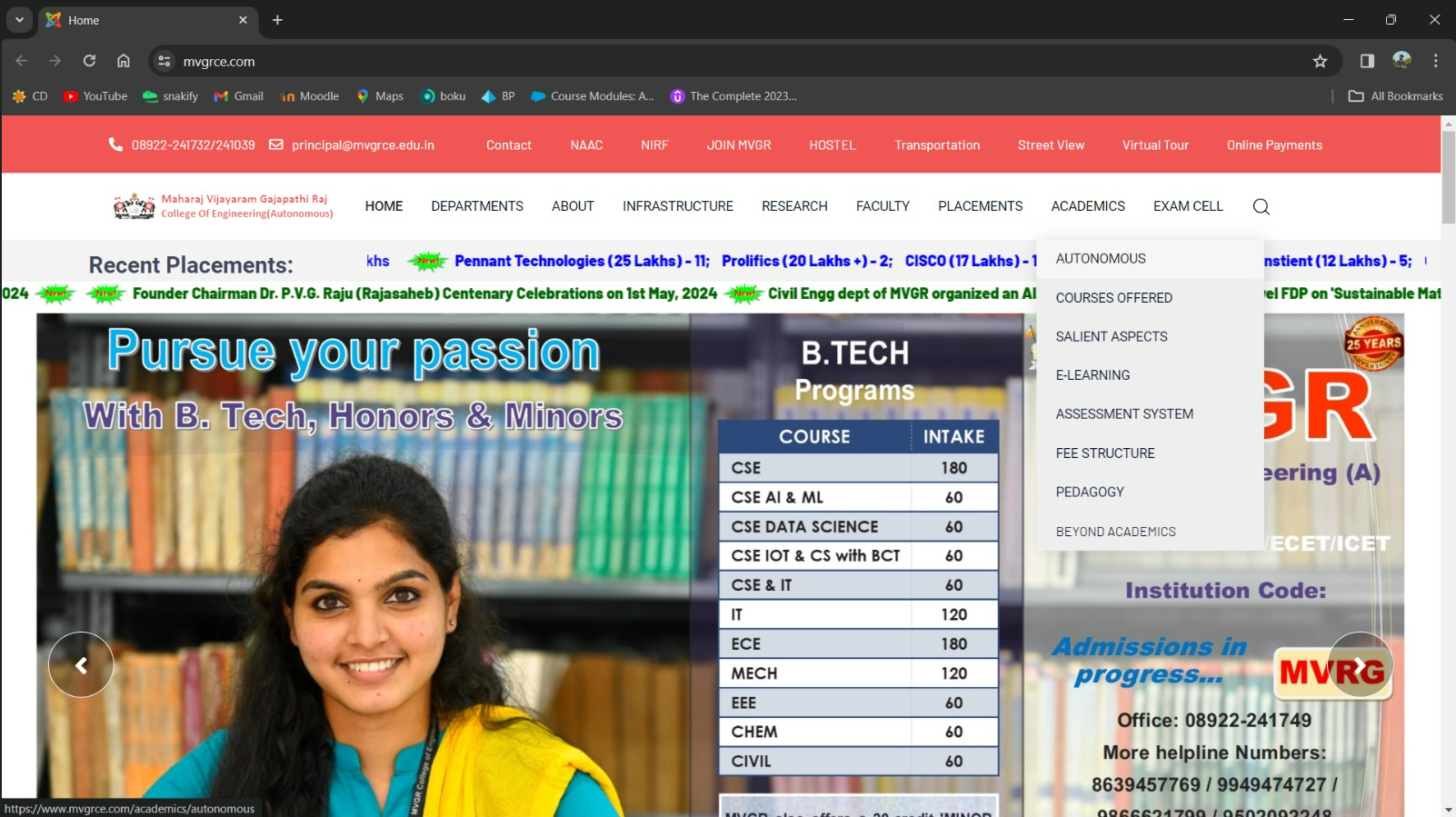

This is the output when I asked the assistant to open Instagram:

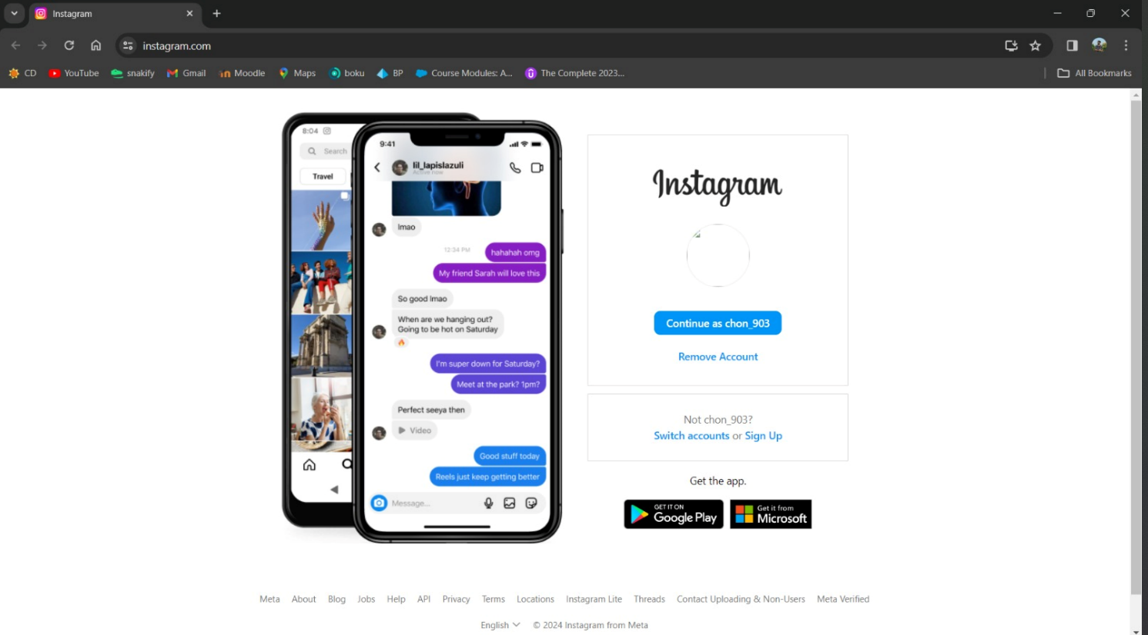

This is the output when I asked the assistant to search for the ipl

